Julius Ranoa

CSC 121 001 Computer Science I

Homework – Chapter 10 Pointers

**Part I. Review Questions @ Page 697.**

Qn. 1 – 11, 13.

1. Each byte in memory is assigned a unique address.
2. The & operator can be used to determine a variable’s address.
3. Pointer variables are designed to hold addresses.
4. The * operator can be used to work with the variable a pointer points to.
5. Array names can be used as pointers and vice versa.
6. Creating variables while a program is running is called dynamic memory allocation.
7. The new operator is used to dynamically allocate memory.
8. If the *new* operator cannot allocate the amount of memory requested, it throws exception.
9. A pointer that contains the address 0 is called a(n) null pointer.
10. When a program is finished with a chunk of dynamically allocated memory, it should free it with the delete operator.
11. You should only use the *delete* operator to deallocate memory that was dynamically acquired with the new operator.
12. Look at the following code.  
    int x = 7;  
    int *ptr = &x;  
    What will be displayed if you send the expression *\**iptr to cout? 7  
    What happens if you send the expression ptr to cout? The address of x in memory.

**Part II. Programming Challenge @ Page 701.**

Qn. 13 – Indirect Sorting Through Pointers #1.

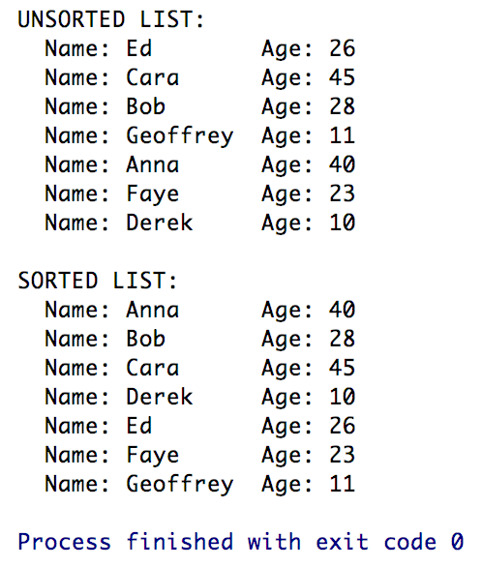

Screenshot of Runtime:

Source Code:

1. *PersonList.h*
2. *PersonList.cpp*
3. *main.cpp*

The source code is also stored at Github.

Link below:

<https://github.com/TheLoneWoof1102/FA17_CSC121001/tree/master/Source%20Code/>

**main.cpp**



***// END of main.cpp.***

**PersonList.h**



***// END of PersonList.h.***

**PersonList.cpp**



**// *PersonList.cpp continued on next page.***

**PersonList.cpp**

***// END of PersonList.cpp.***